**Emotion detection from text**

Dr. D. Ramesh1, G.TharunTeja2,G.shiva3, M.srujala4

1.Assistant Professor in School of Computer Science and Artificial Intelligence,SR University,Warangal,Telangana State.

2,3,4 School of Computer Science and Artificial Intelligence,SR University,Warangal,Telangana State.

**Abstract**: Artificial Intelligence has been used to interpret data to make decisions and understand the emotions of humans. Sentiment analysis is a technique for determining people's attitudes, feelings, and emotions about a certain purpose, such as people, or organizations. Since the emergence of the internet, individuals have used text messaging as a source to communicate with each other. As a result, in today's virtual community, robots must interpret emotions in views, comments, and textual exchanges to give emotionally aware replies to users. Emotion detection is a subtype of sentiment analysis in that it predicts a specific emotion rather than just reporting good, negative, or neutral. Many researchers have previously worked on voice and facial expressions for emotion identification in recent years. However, detecting emotions in the text is a time-consuming operation. Emotions are easily recognized by humans, but the true issue emerges with technology. To discern emotions in text, machines require an accurate algorithm. This study uses a data set from open-source Kaggle. Our algorithm, unlike previous research, can detect emotions from text with an at most accuracy of over 58%.

**Keywords**: Sentiment Analysis, Artificial Intelligence

**1. Introduction:**

AI has made a big impact on the globe. AI was reintroduced in a significant manner in the twentieth century, and it inspired researchers to perform in-depth studies in domains like NLP, and machine learning. However, the domains of NLP remain ambiguous due to its computational methodologies, which assist computers in understanding and producing human-computer interactions in the form of text and voice. Emotion is a strong sensation caused by one's surroundings, mood, or interactions with others. Emotions are really complicated. Emotions, according to some beliefs, are a state of feeling that causes physical and psychological changes that impact our behavior.

The relevance of emotion recognition from text is rapidly increasing with the Internet. As a result, technologists, and political analysts have emphasized and wish to use this sector in all aspects of decision-making to better enterprises, reputations, and so on. The Internet provides online social networking sites such as Facebook, YouTube, and Twitter. Speech, facial expressions, and text-based emotion can all be used to express emotions. Text messages are used to communicate. Humans can quickly perceive emotion, while machines have a greater deal of difficulty. To discern emotion in text, machines require an accurate algorithm. Text-based recognition is also beneficial to psychologists.

Emotions include joy, sadness, rage, surprise, hatred, fear, and so forth. The emotion-detecting system formally divided human feelings into six groups at the main level, which are Love, Anger, Joy, Fear, Sadness, and Surprise. Certain additional terms are also classified as secondary levels. Emotion identification from text is a relatively new classification job, and advances in the textual analysis have made emotion detection a recent subject in the field of Natural language processing. The subject of how to identify emotion from text remains unanswered. So, our major goal is to extract emotion from the text at the sentence level with the greatest accuracy possible.

**2. Related Work:**

Based on the Research, There are several techniques that are used to identify emotions in text few are:

**Keyword-based detection:** Emotions are detected based on the related set(s) of keywords found in the input text.

**Learning-based detection:** Emotions are detected based on previous training result with respect to specific statistic learning methods.

**Hybrid detection:** Emotions are detected based on the combination of detected keyword, learned patterns, and other supplementary information.

Several research have been conducted using various methodologies to identify emotions in text.

Mostafa Aref et al [1], the authors offered an electronic deep research model that categorizes tweets with numerous sorts of embedded phrases CNN is the core component of our approach, and terminology are based on it. The achieved accuracy is 78. The word embedding started on its own, and the highest accuracy for Word2Vec is 84.99c.

Seal et al [2], emotion identification was carried out using a keyword-based strategy that primarily targeted phrasal verbs. They preprocessed the ISEAR data, employed the keyword-based technique, and then used the results. They identified several phrasal verbs that ought to be connected to emotion categories but weren't, so they created their own database. They identified phrasal verbs and terms that were interchangeable with different emotions and classified them using their database. They did, however, surpass the researcher's preexisting problems, such as an inadequate list of emotion keywords and a disregard for word semantics in meaning, by achieving a significantly greater accuracy of 65%.

Santosh Kumar & Rajeev Kumar Gupta et al [3] proposed a model that the pipeline first received the text as an input, and it then transformed the text into a vector. The ML Classifier was trained using these vectors. Second, the pre trained word vector was used to extract the features and the embedding matrix (18210, 300) served as the DL model's input layer. The DL model was used to train the padded vector. Used a hybrid model (deep learning + machine learning) SVM, CNN, BI-GRU and found an accuracy over 80.11%.

Kashif khan & Sher Hayat et al [4] conducted experiments on the text emotion dataset to test the efficiency of the proposed method for social emotion detection. It includes thirteen reader feelings. Preprocessing begins by breaking each text into sentences using sentence boundary recognition, followed by deleting stop terms, numbers, person names, punctuation, and words that occur in less than three documents. Naive bayes classifier, linear SVM, Logistic regression and Random forest are used and found greater accuracy of over 80% using random forest.

Jianpei Zhang, Jing Yang et al [5], and the current research suggests a hybrid controlled sentiment analysis method based on one of the two approaches. A training phrase is used to gather the classifier from a small collection of labelled data using the Lexicon-based technique for learning confidence parameters. An evaluation set in Naive Bayes is then used to create a classifier for feelings. The classification for lexical sensory polarity and the experienced classifier come last. The Naive Bayes framework for investigating sensations is described.

Man Sherine Rady, &Mostafa Aref et al [6] the authors proposed an Electronic profound model of study that classifies tweets with various types of embedded words. CNN is the key part of their model, and terms are rooted in the central facets. The accuracy reached is 78. The word embedding spontaneously begun and maximum precision is 84.99c for Word2Vec.

Aditya Dave, Santosh Bharti et al [7] in order to provide a framework for the detailed analysis of sentiment that provides us with real-time sentiments for a case, business, or individual in the audience on the microblogging website Twitter, this article leverages existing sentiment analysis techniques. With the use of this technique, people may understand the perceived image of the scenario. This input might be utilised to improve the current situation if it is given in a timely manner.

**3. Methodology**

**3.1 Problem Formulation**

Researchers have been inspired to investigate internet resources and examine users' online social activities as a result of the development and popularity of social networks. Customer, or product reviews are crucial for businesses to understand customer attitudes and habits as well as for consumers to make purchasing decisions. Additionally, chat bots or conversational agents are being adapted in industries such as healthcare to monitor and automate the delivery of healthcare services, business to improve service quality, and education to promote meaningful interaction in distance learning or online learning to maintain market competitiveness. Therefore, it is crucial to research emotions from the text in many application fields. With the advancement of the internet, people share and express their thoughts through text messaging applications. Hence, it is essential for machines to understand emotions in opinions, feedback, and textual dialogues to provide emotionally aware responses to users in today's online world. So our primary objective is to extract emotion from text at sentence level with at most accuracy.

**3.2 Data Insights**

This paper Data set was obtained from open source Kaggle website. Data set contains 2 columns, Text, and Emotions. Emotions Column has various categories like sadness, anger, joy, surprise, fear, disgust, shame and happy,. Data set consist of 28586 unique sentences with their corresponding emotion. The data set was preprocessed and then it was model was trained using this data set. The test size is 0.20 and training size is 0.8 which means 20% used for testing and 80% for training. Our data set can recognize emotions like sadness, anger, joy, surprise, fear, happy, disgust, shame .

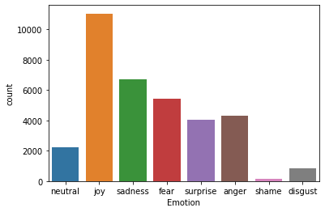

**Fig.1. Emotion and count Graph**

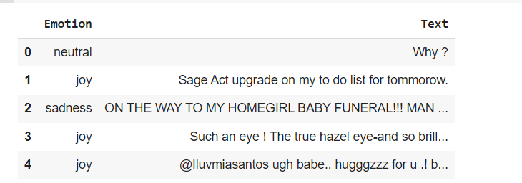

**Fig.2 Data Set Sample**

**3.3 Model Architecture**

In our Proposed Model we are using GloVe embedding technique and BI-LSTM. Bidirectional long-short term memory is the process of making any neural network have the sequence information in both directions backwards (future to past) or forward (past to future). GloVe stands for Global Vectors for word representation, is an unsupervised learning algorithm for obtaining vector representations for words. Training is performed on aggregated global word-word co-occurrence statistics from a corpus, and the resulting representations showcase interesting linear substructures of the word vector space. The proposed model consists of data collection and data preprocessing. After preprocessing the data by removing stop words, the corpus is passed to glove embedding layer and converted to one hot representation and finally it is passed to CNN Model which uses BI-LSTM.

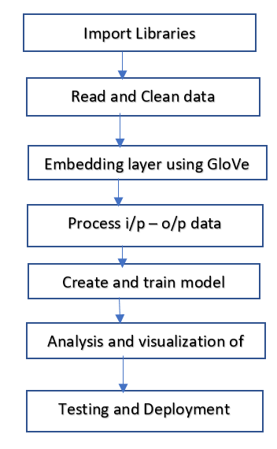

**Fig.3.** Process Flow

We created a NLP model by using GloVe embedding technique and BI-LSTM. Firstly, we have imported the required libraries and read Csv file. We then performed missing value treatment by dropping rows with NA values. Removed special Characters and Stop words and then added glove word embedding layer it aims to generate word embedding’s by aggregating global word occurrences matrices from corpus. Performed One hot representation for input and initialized our model to sequential () and used a CNN architecture for BI-LSTM. Added embedding layer that can be used for neural networks on text data. It requires that the data to be integer encoded, so that each word is represented by unique value.it is initialized with random weights. Added dropout layer. It is a regulation technique where randomly selected neurons are ignored during training and added bi directional LSTM layer. We added dense layer with relu activation function and later added dense layer with SoftMax activation and compile.

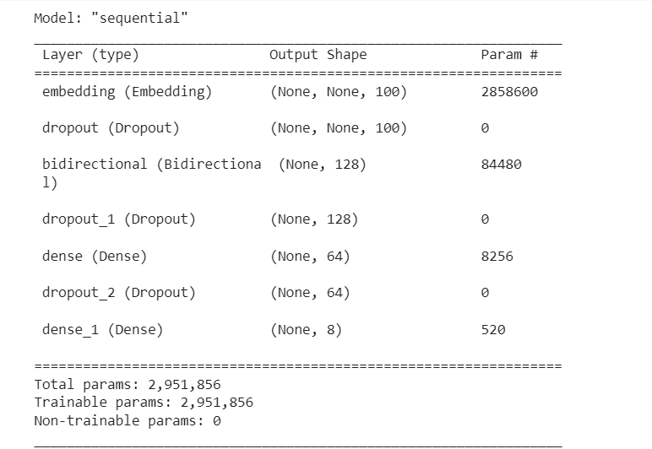

**Fig.4**.Model Summary

**4. Results Analysis**

**4.1 Model performance**

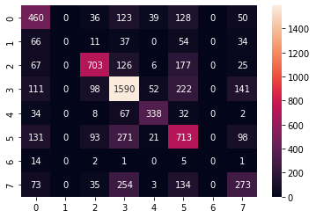

**Fig.5.** Confusion matrix

For evaluating the performance of the proposed model training and testing accuracies are very useful. To get better accuracy the model needs to be trained using different epochs. We trained the data set using our model. We used 50 epochs to train the data. We found the accuracy of our proposed model is 58%.

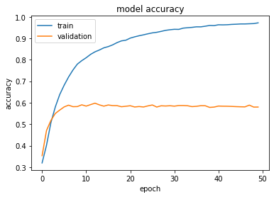

**Fig.6.** Model accuracy train and validation vs epochs

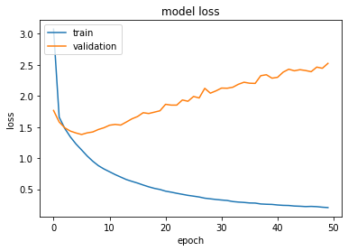

**Fig.6.** Model loss train and validation vs epochs

**4.2 Comparative Results Analysis**

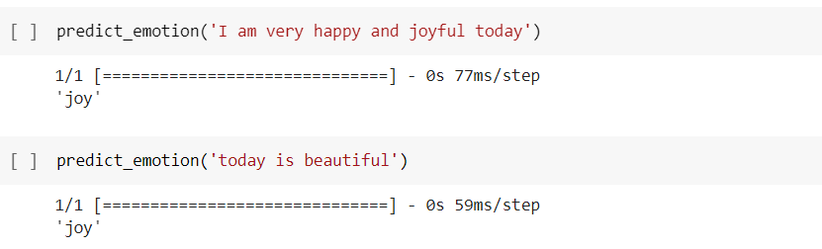

The above text consists of words like happy and joyful and beautiful which are related to emotion ‘joy’.

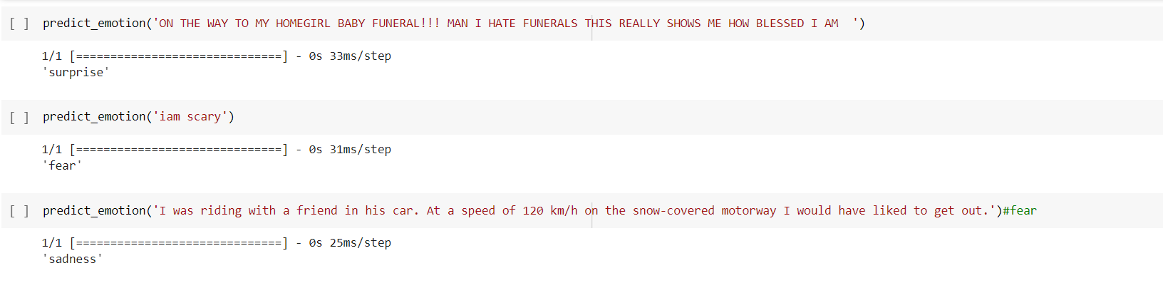

In the above texts we can observe the words ‘scary’ are emotion which are related to emotion ‘fear’, ‘sadness’.

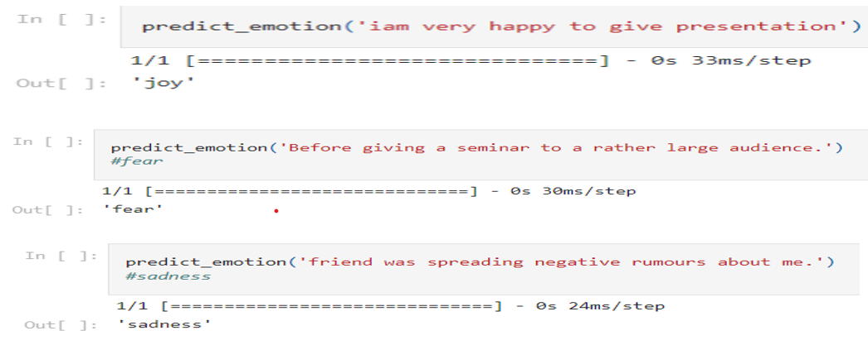

**5. Conclusion**

Emotion detection is an important area of study in human-computer interaction. Researchers, have done enough work to recognize emotion from audio and visual data, but understanding emotions from textual data is still a new and active study topic. This paper discusses that the novelty of discovering relevant texts emotions plays a critical role in this work. In this study, we explore the model's ability to predict sentiments. In this article, we employed the BI-LSTM and GloVe embedding technique and created a machine learning model that predicts the emotion from the text. The accuracy obtained was over 58%.

**References**

[1] ditya Dave, Santosh Bharti, Samir Patel, and Sam bit Kumar Mishra, “A Real-Time Sentiments Analysis System Using Twitter Data”, O Springer Nature Singapore Pte Ltd. 2021, D. Mishra ct al. (eds.), liitelligetit u+id Cloud Computing, Srnan Innovation, Systeriis and Technologies 153.

[2] Hongyu Han, Yongshi Zhang, Jianpei Zhang, Jing Yang, and Yong Wang, “A Hybrid Sentiment Analysis Method”, Springer Nature Singapore Pte Ltd. 2021, Q. Liu et al. (Eds.): CENet 2020, AISC 1274, pp. 1135-1146, 2021.

[3] Sherine Rady, and Mostafa Aref, “A Deep Learning Architecture with Word Embeddings to Classify Sentiment in Twitter”, Springer Nature Switzerland AG 2021, A. E. Hassanien et al. (Eds.): AISI 2020, AISC 1261, pp. 115-125,0032021

[4] D. Seal, U. K. Roy, and R. Basak, “Sentence-level emotion detection from text based on semantic rules,” Information and Communication Technology for Sustainable Development, Springer, Singapore, pp. 423–430, 2020.

[5] Santosh Kumar Bharti, S Varadhaganapathy, Rajeev Kumar Gupta, Prashant Kumar Shukla, Mohamed Bouye, Simon Karanja Hingaa, Amena Mahmoud, "Text-Based Emotion Recognition Using Deep Learning Approach", *Computational Intelligence and Neuroscience*, vol. 2022, Article ID 2645381, 8 pages, 2022. https://doi.org/10.1155/2022/2645381

[6] Khan, Kashif & Ejaz, Muhammad. (2016). Emotion Detection through Text.

[7]Nourah Alswaidan, Mohamed El Bachir Menai, “A survey of state-ofthe-art approaches for emotion Recognition in the text”, ©SpringerVerlagLondonLtd.,partofSpringerNature2020.